**Project Design Phase-II**

**Data Flow Diagram & User Stories**

|  |  |
| --- | --- |
| Date | 20 June 2025 |
| Team ID | LTVIP2025TMID55793 |
| Project Name | FreelanceFinder: Discovering Opportunities, Unlocking Potential |
| Maximum Marks | 4 Marks |

**Data Flow Diagrams:**

A Data Flow Diagram (DFD) is a traditional visual representation of the information flows within a system. A neat and clear DFD can depict the right amount of the system requirement graphically. It shows how data enters and leaves the system, what changes the information, and where data is stored.

**Example:** [**(Simplified)**](https://developer.ibm.com/patterns/visualize-unstructured-text/)

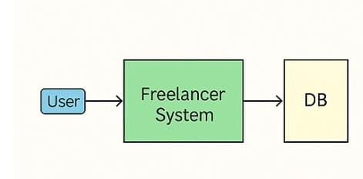 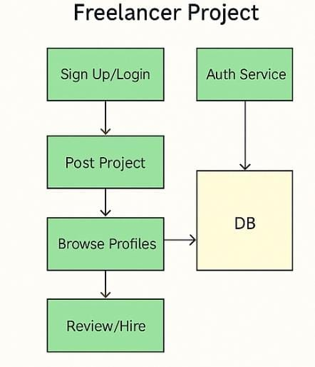

* User sends request (register, login, browse books, order, wishlist)

Data flows:

* From user to system through login, book filters, wishlist, and cart interactions
* System reads/writes to MongoDB (user, book, order, wishlist collections)
* System responds with book list, dashboard, confirmation
* System stores/updates data in MongoDB

**User Stories**

| **User Type** | **Functional Requirement (Epic)** | **User Story #** | **User Story / Task** | **Acceptance Criteria** | **Priority** | **Release** |
| --- | --- | --- | --- | --- | --- | --- |
| Client/customer | Registration | USN-1 | As a user, I can register with email and password. | I can access my dashboard | High | Sprint-1 |
| Client | Login | USN-2 | As a client/user, I log in using email and password | I can access my dashboard | High | Sprint-1 |
| Client | Project Posting | USN-4 | As a client, I can Post a new Project within a detailed description | Project visible to the freelancer | High | Sprint-1 |
| Client | Project management | USN-5 | As a client,I can review freelancer bids for my projects | I can select the freelancer. | High | Sprint-2 |
| Client | Communication | USN-6 | As a client, I can communicate with freelancer | Messages sent and receive us | High | Sprint-2 |
| Client | Project Review/feedback | USN-7 | As a client,I can review the project submitted by freelancer | I can provide feedback and request revision | Medium | Sprint-3 |
| freelancer | Registration /login | USN-8 | As a freelancer,I can register and next log in with using email and password. | I can access the freelancer dashboard | High | Sprint-1 |
| freelancer | Profile management | USN-9 | As a freelancer, I can add and update my profile with skills and portfolio. | Profile is updated and visible to clients | High | Sprint-2 |
| freelancer | Project browse/bidding | USN-10 | As a freelancer,I can browse project and submit bids on projects . | Bid is recorded and visible to the clients | High | Sprint-2 |
| freelancer | Project submission | USN-11 | As an freelancer ,I submit the projects | Client view the submitted work | High | Sprint-3 |
| Administrator | Admin dashboard | USN-12 | As an admin, I can manageall users(clients and freelancer) projects,and transcations | Admin panel updates backend & reflects in UI | High | Sprint-4 |
| Administrator | User Management/project Oversight | USN-13 | As an admin, I can approve or suspend user accounts. monitor ongoing projects and resolve disputs. | User account status is updated and disputs resolved and project status is updated. | Medium | Sprint-4 |